Luis Medina
012020203
D602 Task 2

For this document I am going to explain the project, along with the steps I took to be able to complete it, along with the complications I had through the project. So, for this project I implemented a complete machine learning pipeline for predicting departure delays at Los Angeles International (LAX) by using data from Bureau of Transportation Statistics. The MLOps workflow consists of three stages: data import, data cleaning, and model training. For each step of the process, I created a separate python script, and it can be used with MLflow. The predictive model is a polynomial ridge regression that uses scheduled departure time, scheduled arrival time, and destination airport as input features to predict departure delay in minutes.
Part B: Import and Format Script
For this part of the project, I created two versions of the data import script, to show improvements made in the first version. For the first version I implemented a straightforward approach. The raw CSV file is loaded using pandas, columns are renamed to match the format from the given file and then save the newly edited CSV file. For version two, I introduced several improvements, like the file is now loaded with the utf-8-sig encoding parameter and low memory is equal to false to prevent errors. A validation step was added to check for missing columns that were expected before renaming them, and numeric type enforcement is applied to all time and integer fields. Also, all the logic was inside the import_data() function to improve readability and reusability.
One of the challenges I faced during this process was mapping the columns names to the format of the provided template, as the dataset uses field names that differ from the model’s expected column names. Then, Data Version Control (DVC) was added into this step to track the raw data I downloaded. I ran the dvc init command so that it does not push the CSV file into GitHub instead it created a lightweight metafile containing the has and size. This was then committed and push to the repository I will be submitting later in the assignment.
Part C: Data Filtering Script
For this part of the assignment, I once again created two scripts to filter and clean the data that was downloaded from the website. For the first version I filtered out the airport that I am focusing on for the assignment, which was LAX and to only retain the rows that have LAX. Next, I filtered out the data to only include data for the month of January 2025, as the format for the polynomial regression model’s train/test spilt only accounts for one month. For version 2 of the script, I added three additional cleaning steps on top of the previous ones from version 1. Each step was once again logged with the count of rows removed to provide version control and transparency. The new step added was to remove duplicates, and here I used the drop_duplicates() method to eliminate any repeated flight records that can later introduce bias into the model training process. The fourth step added was the removal of Null from the column DEPARTURE_DELAY, the nulls were dropped, since these records cannot be used for training or evaluation purposes. Lastly, the final step added to version 2 was the removal of Null from the column SCHEDULED_DEPARTURE. Rows that were missing values from this column are dropped as this column is required for the train/test split and feature engineering steps in the model.
Part D: MLFlow Experiment
For this part of the assignment, I used the file poly_regressor_Python that was provided as a template. The model that was provided uses Ridge regression with polynomial features to predict departure delay from the scheduled flights, scheduled arrival time, and destination airport. The way the data is split is that the first 22 days of the month are used for training and the rest of the days are used for testing. The way the training is done is by iterating over a range of Ridge penalty alpha values that this loop through them. Also, since each alpha is evaluated as a nested MLflow run you can compare individual metrics in the MLflow UI.
For version 1 (poly_regressor_Python_v1) logged the following to MLflow for each nested training run.
- Parameter: alpha, which is the Ridge regression penalty value for that run
- Metric: Training data Mean Squared Error
- Metric: Training data Average Delay
The final run will log the following artifacts and metrics against the test dataset:
- Artifacts: import data log, clean data log, model performance test (files included)
- Parameters: alpha best value, order polynomial degree
- Metrics: test data Mean Squared Error, test data average delay.
Now for version 2 and the improvements to the file, in this one I introduce the polynomial order as a configurable argument using argparse. The order parameter will also be logged in every nested MLflow run in version 2, whereas version 1 was only logged onto the final run. This will allow direct comparison of experiments run with different polynomial degrees in the MLflow UI. For the challenges faced in this part of the assignment, was first the format_hour() function had a string format ({0:04d}) that was giving me an error. I later found out that the reason for this error was that because of the newer version of Python it had a conflicting brace syntax. I just had to update the format to ({:04d}) and then I was able to run the script just fine. The second problem I ran into was that the performance plot generation used two-dimensional array indexing, which gave me an IndexError when the Ridge regressor returned a one-dimensional array. This one was probably one of the challenges that took me a while to fix before finally getting it to work.

Part E: MLProject Linking File
For this part of the assignment, I created the file MLProject, which has three entry points, import data, clean data, and train model. In the file I reference the given pipeline_env.yaml file that was given to me before the assignment, this just ensures that all the pipeline stages execute within a consistent, reproducible environment regardless of the computer used. The first entry point, import data, this will execute the file import_data_v2.py to load and format the raw data that we downloaded. Then the next entry point, clean data, and this will execute the file clean_data_v2.py and this will apply all the cleaning steps mentioned above. Lastly the final entry point, train model, and this will execute the poly_regressor_Python_v2.py with two configurable parameters, num_alphas and order. By having this configuration, it will provide some useful benefits, as it will ensure the same package versions are used across different machines and environments. Then by using the parameters in the entry point, it will allow us to rerun with different configurations without changing the source code. Then by using the DVC data tracking from the previous part and MLflow, it allows the pipeline to provide end-to-end traceability from raw data through to trained model artifacts.
Part F: Explanation
Here I will include the screenshots of my MLProject pipeline running successfully. 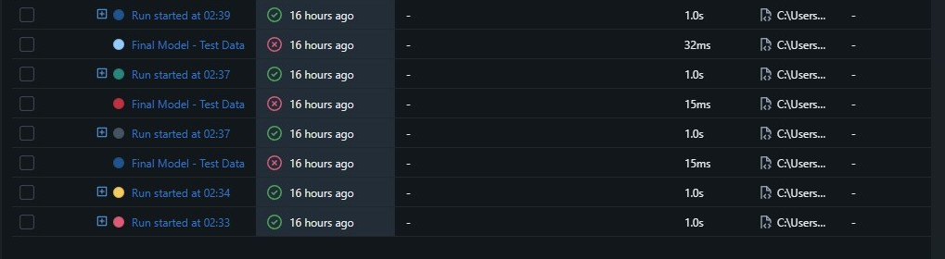
Here is the screenshot for version 1 and the screenshot for version 2.
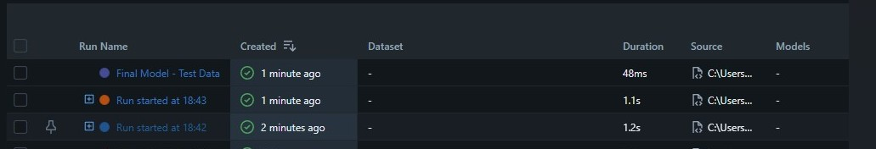
Those are both screenshots of it running.
Part G: Sources
Bureau of Transportation Statistics. (n.d.). Reporting carrier on-time performance (1987-present). U.S. Department of Transportation. https://www.transtats.bts.gov/

DVC. (n.d.). Data Version control documentation. https;//dvc.org/doc

MLflow: A Tool for Managing the Machine Learning Lifecycle | MLflow. (n.d.). https://mlflow.org/docs/latest/ml/

